Assignment 11: For Problems 1-4, give the following. Use the example on page 10 in the chapter as a model. To receive full credit, identify the following:

- growth rate (or decay rate)
- growth factor (or decay factor)
- a general equation using exponents
- answer the questions.

Setting up a table is sometimes helpful, but it is optional. Round populations of people, animals, cells, to whole numbers. Round money to dollars and cents or just dollars. Round at the end of all your calculations.

Problem 1

Suppose the population of a small country is 950,000. If the population is growing at an annual rate of 4%,

a) What will the population be in 10 years?

b) What will it be in 25 years?

c) How long will it take for the population to reach 3 million? Remember “trial and error.”

Solution

Calculating Average Annual (Compound) Growth Rates

For problems a and b, we will use the following formula to calculate the AAGR (Average Annual Growth Rate) when given a quantity of time:

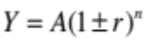

Similarly stated otherwise:

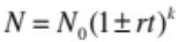

Where N or Y is the future value, 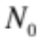 or A is the present value, r is the growth rate, t is the units of time, and k or n is the quantity of time.

a)
= 1406232

b)
= 2532545

For problem c, we will use the following formula to logarithmically calculate the AAGR when given the future value without a quantity of time:

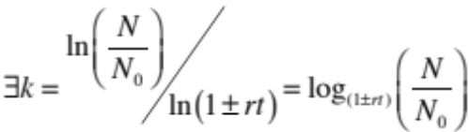
c)
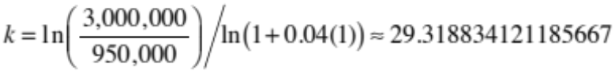
Approximately 29 years and 4 months.

Problem 2

Suppose that the population of an endangered species is 15,000. If the population is decreasing at an annual rate of 3.5%,

a) What will it be in 10 years?

b) What will it be in 25 years?

c) How long will it take for the population to reach 3,000?

Solution

Using the same polynomial time algorithms as above:

a)
=10504

b)
= 6156

c)
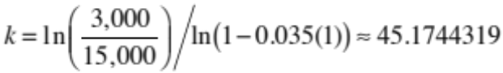 = 45

Problem 3
If you have one bacterium in a test tube and it doubles every minute, how many bacteria will you have in:
a) one hour?

b) one day? Note: Your calculator may give you an error if the number is too large.
Leave your answer as a number with an exponent.

EXTRA CREDIT-1 point: If you understand how to manipulate exponents, (given in the beginning of this handout) you can break down your answer into a number with an exponent that will work in your calculator. Write your final (correct) answer in correct Scientific Notation for extra credit.

Solution
Using the following formula:
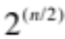
a)
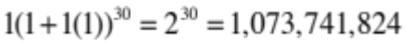
b)

Problem 4
Suppose the time it takes for the earth to make one daily rotation increases 5% per billion years. If the length of an hour is assumed constant, how many hours long will a day be just before the sun novas (exploding just before its death), destroying Earth, five billion years in the future?
Hint: How many hours are there in a day right now? You will be increasing this amount.

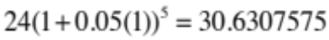 = Round? (31)

Problem 5 Everything you need for compounding more than once per year is in the handout. Just be careful in substituting into the formula. Be careful not to round too soon or too much!

You deposit $7,500 into a bank account and leave it there for nine years at an interest rate of
2.4%. How much will you have at the end of nine years if the interest is a) compounded annually
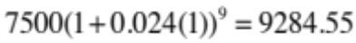
b) compounded semi-annually?

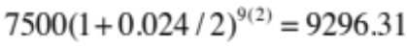

c) compounded quarterly?

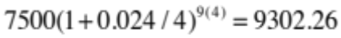

d) compounded monthly?



Problem 6 - Extra Credit – 1 point: No hints or extra help on this problem! It is not more difficult than any of the others. The difficulty is only in the conversions.

For the past few months the city of New Orleans has been plagued by a dangerously high
level of unusual coliform bacteria in the drinking water. At the temperature of the water in their main reservoir, a coliform population is known to grow by 6.2% per day!!!

Assume the following:

a) Only 12 bacteria were initially introduced into the reservoir to start this outbreak.

b) The infected reservoir contains 2.3 million gallons of water. (Be careful of units!!)

c) Measurements show a bacteria count of 20 coliforms per quart.

QUESTION: How long ago were the original 12 coliforms introduced into the water?

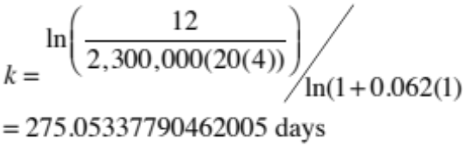

rounded to 275 days.
THE NEXT FEW PROBLEMS ARE ON SCIENTIFIC NOTATION, PERCENTS, and EXPONENTS. Problem 7 - Write the following numbers in Scientific Notation.
a) The mean distance from the Sun to Mars is about Two Hundred Ten million miles. b) The time it takes for light to travel 1 mile is .00000538 seconds.
a) 
b) 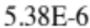

Problem 8 – Write the following numbers in expanded form. i.e. not in scientific notation.
a) 13.6 x 106
13,600,000

b) 3 x 10-5
0.00003

Problem 9 – Do the following percent problems the SHORT WAY, i.e. in one step. Show your formula.
a) Increase $1500 by 7%.
1500(1+.07) = 1605
b) Decrease $600 by 3.6%

600(1-0.036)=578

Problem 10 − Practicing with Exponents:

a)

b)

c)

d) Hint: Do the numerator first.

a) 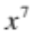
b) 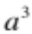
c) 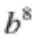
d) 